2 Year Old Class  Supply List  Please provide the following items for your child’s classroom. They will be used throughout the year.  If your child is not fully potty trained please provide diapers and wipes as needed. Pull Ups are not allowed. Thank you.  O 3 -80 Count or Larger Packages of Baby Wipes  O 1 Large Box of Facial Tissue  O 3 Containers of Clorox/Lysol Disinfecting Wipes  O 1 Crayola Water Color Set with the 8 Basic Colors  O 8 Basic Color Jumbo Crayons  O 3 Large Glue Sticks  O 1 Multi-Colored Pack of Low Odor Dry Erase  Markers with Dry Eraser  Please include the following in a gallon sized Ziploc bag. Please write your child’s name on the bag:  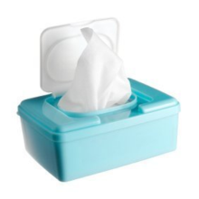  O 3 Pairs of Underwear  O 3 Pairs of Pants or Shorts  O 3 Shirts  O 3 Pairs of Socks  O 1 Pair of Close Toed Shoes | 3 Year Old Class  Supply List  Please provide the following items for your child’s classroom. They will be used throughout the year. Thank you.  O 2 -80 Count or Larger Packages of Baby Wipes  O 1 Large Box of Facial Tissue  O 3 Containers of Clorox/Lysol Disinfecting Wipes  O 1 Crayola Water Color Set with the 8 Basic Colors  O 8 Basic Color Jumbo Crayons  O 3 Large Glue Sticks  O 1 Multi-Colored Pack of Low Odor Dry Erase  Markers with Dry Eraser  Please include the following in a gallon sized Ziploc bag. Please write your child’s name on the bag:  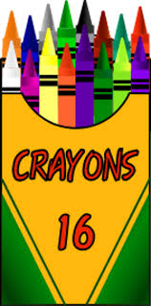  O 2 Pairs of Underwear  O 2 Pairs of Pants or Shorts  O 2 Shirts  O 2 Pairs of Socks  O 1 Pair of Close Toed Shoes
4 Year Old Class  Supply List  Please provide the following items for your child’s classroom. They will be used throughout the year. Thank you.  O 2 -80 Count or Larger Packages of Baby Wipes  O 1 Large Box of Facial Tissue  O 3 Containers of Clorox/Lysol Disinfecting Wipes  O 1 Crayola Water Color Set with the 8 Basic Colors  O 8 Basic Color Jumbo Crayons  O 3 Large Glue Sticks  O 1 Multi-Colored Pack of Low Odor Dry Erase  Markers with Dry Eraser  Please include the following in a gallon sized Ziploc bag. Please write your child’s name on the bag:  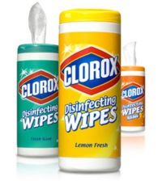  O 1 Pair of Underwear  O 1 Pair of Pants or Shorts  O 1 Shirts  O 1 Pairs of Socks  O 1 Pair of Close Toed Shoes | Napping Students  If your child is staying for nap please provide the following in a tote bag.  O Fitted Crib Sheet  O Crib Sized Blanket  O Small Pillow (Optional)  O Stuffed Animal (Optional)  Please write your child’s name on all items including the tote bag.  All items must be take home, washed, and returned weekly.  *Misplaced items without names will be put in the Lost and Found basket at the Pre-School entrance.  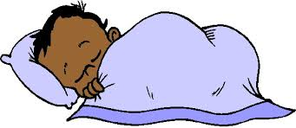
Classroom Supplies 03 15 18

